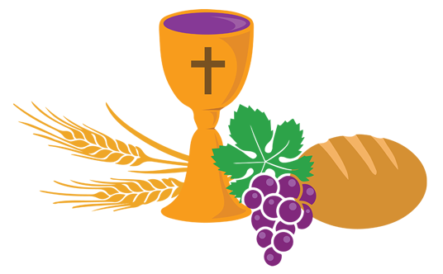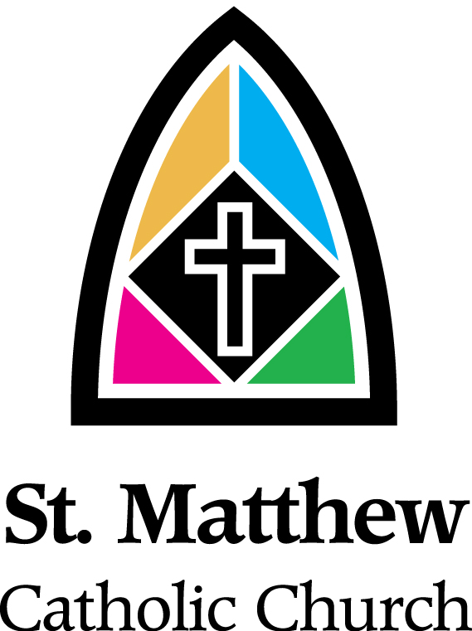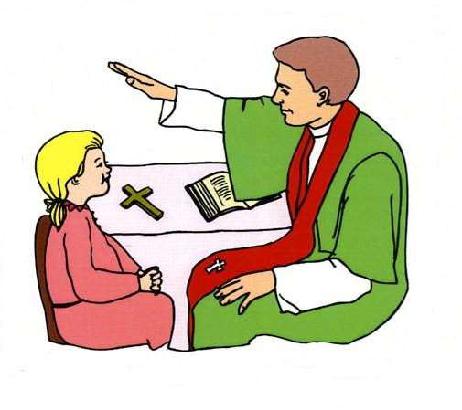

Sacrament Preparation Program St. Matthew Parish
First Reconciliation/First Eucharist

The program
Parents have three choices for their children’s Sacramental Preparation Program……
Choice A: Children are Public or Homeschool Students who enrolled and prepared in St. Matthew’s FAMILY OF FAITH Religious Education Program that meets monthly. They are taught by catechists in the classroom (and supported by their families) for the Sacraments of First Reconciliation and First Eucharist School
Choice B: Children are enrolled in St. Matthew’s School. They are taught a weekly Sacramental Prep lesson by their homeroom teacher in the classroom (and supported by their families) for the Sacraments of First Reconciliation and First Eucharist.
Choice C: Children are in enrolled in both St, Matthew’s school and the FAMILY OF FAITH program. And are taught by both catechists and classroom teachers (and supported by their families) for the Sacraments of First Reconciliation and First Eucharist.
There are opportunities for family engagement at our Jesus Day Retreat and our Blessing Cup Meal.

Eligibility & Age
Sacrament Preparation for First Reconciliation and First Eucharist takes place traditionally during 2nd grade. (Age 7). All of the children must have already been baptized Catholic. If there is a need for preparation for these sacraments at other grades or ages, or if the child is not baptized Catholic, please contact Jeni Lengerich Pleiss and jlengerich@saintmatt.org

Cost
There is no cost for the preparation of these sacraments. However, we do ask families to cover the cost of the Blessing Cup Meal, the Banner Kit, and the Blessing Cup glazing. This expense totals $80.00 and can be paid in 2 installments ($40.00 on October 1 and $40.00 on March 1).

Register
Each Child must be registered online at https://www.saintmatt.org/faith-formation-registration/
By September 6, 2019.

Attendance
Attendance is mandatory at all events. A doctor’s excuse or family emergency will be required for an absence.

Dates and Times of Meetings

First Reconciliation Schedule
session # | date | Time | Location
Rite of Enrollment | 20-Oct | 9:00 AM | Church
First Reconciliation | 19-Nov | 7:00 PM | Church
First Holy Communion Schedule
session # | date | Time | Location
Retreat | 21-Mar | 9:00-Noon | Community Room
Holy Thursday Mass | 9-Apr | 7:00 PM | Church
Blessing Cup Meal | 26-Apr | 5:00 PM | GYM
Rehearsal | 26-Apr | 6:00PM | Church
First Holy Communion | 2-May | 11:00 AM | Church

Reconciliation
Reception of the Sacrament of Reconciliation will take place in a separate reconciliation service one evening in the fall. This is a family service and all family members are encouraged and invited to attend. The evening begins with a communal penance service for the group and several priests are available to hear reconciliations. We encourage all parents to receive the sacrament that evening as well.
Dress is Christian Modesty.

Eucharist
The First Eucharist Liturgy takes place May 2. This is a separate liturgy for the families of the First Eucharist children and their guests. This mass is always 3 weeks after Easter (excepted for 2019, when it conflicted with Mother’s Day and the school calendar). The Children will be receiving as a group and sitting as a group in the first 2-3 pews. Family pews will be reserved behind the children, by last name, alphabetically.
Dress for boys: dark pants, white shirt, dark tie, dark jacket is optional.
Dress for girls: White dress or pantsuit. No floor length or spaghetti strap gowns. Veils are optional.

If you have further questions regarding Sacrament Preparation please contact Jeni Lengerich Pleiss at jlengerich@saintmatt.org or 257-4297 x2215.

