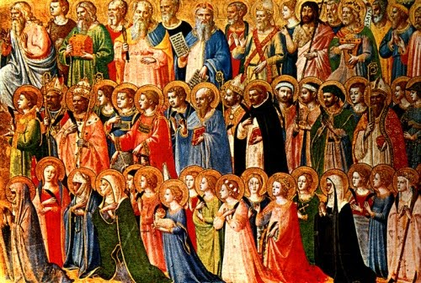

Confirmation Preparation
Saint Name Form

Full Name: ________________________________________________________________
Saint Name Chosen: ________________________________________________________

Tell us something about the life of your saint.

Why did you choose this particular saint for your Confirmation name?

How do you see God in the life of your saint?

