Top 10 Things You Need to Know About Confirmation

- CALENDAR
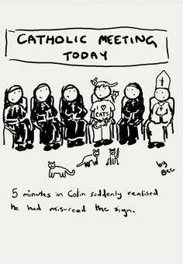

Teens are required to be at all events. While always welcome,
parents and sponsors are only required to attend when indicated.

August 16th: Orientation @ St. Lawrence (Teens & Parents)
In English: 2:00pm-3:00pm
In Spanish: 4:00pm-5:00pm
September 13th: Class via Zoom from 3:30pm-5:00pm (Teens)
All Registration Forms and Baptismal Certificates are due.
October 11th: Class via Zoom from 3:30pm-5:00pm (Teens)
Sponsor Forms are due.
November 8th: Class via Zoom from 3:30pm-5:00pm (Teens)
December 6th: Class @ TBD from 3:30pm-5:00pm (Teens & Sponsors)
Sponsors are required to attend this class.
January 10th: Class @ TBD from 3:30pm-5:00pm (Teens)
February 6th: Retreat @ TBD from 9:00am-4:30pm (Teens)
Presentation of Candidates at Mass times TBD (Teens)
TBD: @ St. Lawrence
TBD: @ St. Matthew
March 28th: Easter Basket Project @ St. Matthew from 1:30pm-2:30pm (Teens)
This is a required service project.
April 18th: Class @ TBD from 3:30pm-5:00pm (Teens)
Saint Forms are due.
May 2nd: Final Class @ TBD from 3:00-5:30pm (Teens & Sponsors)
Sponsors are required to attend the first half of this class (approx. 3:00-4:15pm).
TBD: Rite of Confirmation @ SS. Peter and Paul Cathedral at 7:00pm (All)

- INSTRUCTION – A CELEBRATION OF THE SACRAMENTS

Our instruction component will be a combination of watching videos
uploaded to both the St. Lawrence and St. Matthew YouTube Channels,
attending Zoom calls, and hopefully (pandemic pending) some
in-person classes by the spring semester.

Since candidates are required to watch the videos uploaded to YouTube BEFORE class, our class time will mostly consist of large group opening prayer and possibly an activity, followed by small group time with their catechists, and then back to large group for closing prayer and announcements.

- RETREAT EXPERIENCE

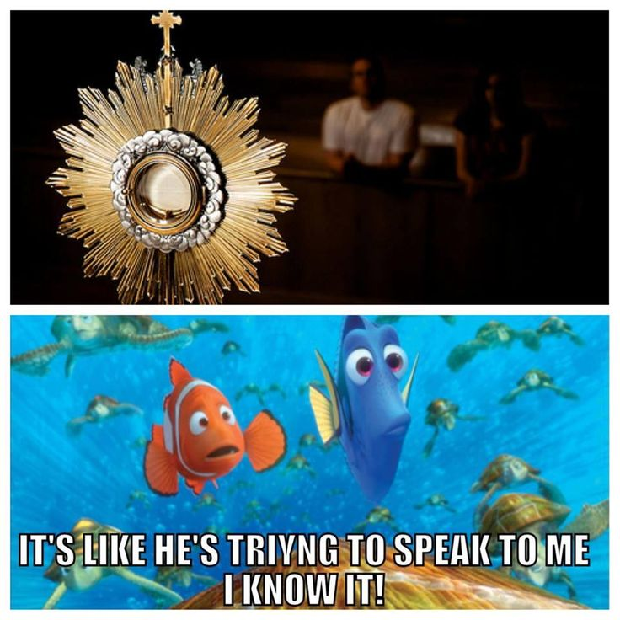

All candidates are required to make a retreat experience
during their preparation for the Sacrament of Confirmation.
As noted on the calendar, the Confirmation Retreat will be
on February 6th. Please see Cari if you cannot make this
date as we will have to research an alternative option.

- CONFIRMATION PAPERWORK DUE BY SEPTEMBER 13th
(Registration Form, Baptismal Certificate,
and at least a Partial Payment)

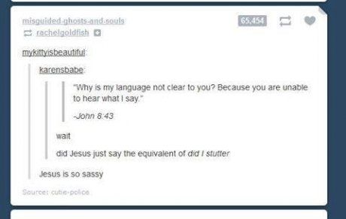

You may complete the required paperwork in one of the following ways:

- Drop-off completed paperwork to your Parish Office
- Mail in completed paperwork to your Parish Office
- Upload completed paperwork to the Google Classroom (more information about this on the last page)
- Complete the Google Form version (available through the Google Classroom)

- SERVICE HOURS

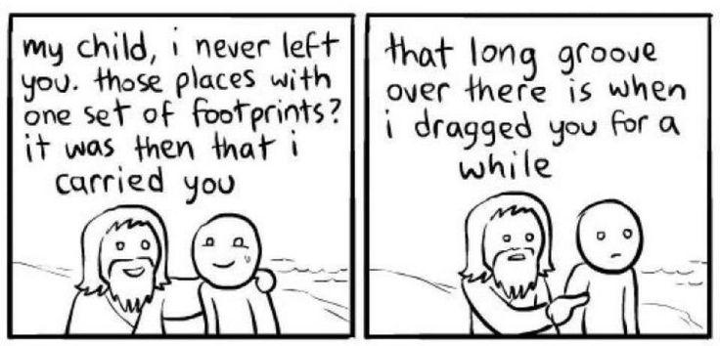

This year, the service requirement is 12 hours for each candidate.

Their hours may fall within the categories of parish, community, or spiritual/self-care hours. These are explained in more detail in the Service Journal.

Please turn in your service journal by April 15th
so we can suggest additional ideas if necessary!

- TIPS FOR CHOOSING A SPONSOR

A sponsor needs to be an active member of the Catholic Church.
A Sponsor needs to be fully initiated in the Catholic Church
through Baptism, Confirmation, and Eucharist

Consider a person you know who is a Christian role model,
who truly lives the Good News. This person must be willing
to share his or her faith with the candidate!

All sponsors are encouraged to be 21 years of age. Cannon Law
requires sponsors to be no younger than 16 and must have
received the Sacrament of Confirmation.

If married, a sponsor must be in a valid marriage
according to the Catholic Church.

- PARENTS’ ROLE

“The initiation of children into the sacramental life is for the most part the responsibility and concern of Christian parents. They are to form and gradually develop a spirit of faith in their children, and with the help of the catechetical institutions, prepare them for the fruitful reception of the sacraments of Confirmation and the Eucharist. The responsibility of parents is also shown by their active participation in the celebration of the sacraments.” (Rite of Confirmation, No. 3)

In other words, you are your teen’s best example of the faith,
so live out your faith to the fullest!

- ATTITUDE IS KEY

The more you put into this experience,
the more you will get out of it!

- STRENGTH FINDERS BOOK

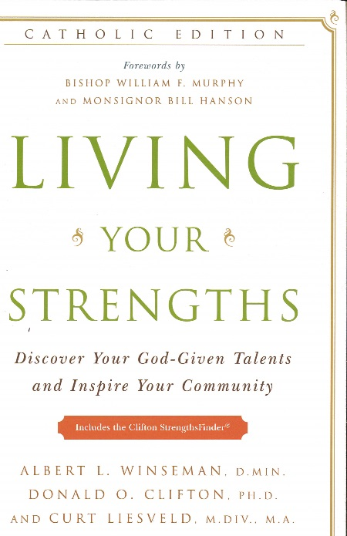

Living Your Strengths
By Albert L. Winseman, D. Min., Donald O. Clifton, Ph.D.,
and Curt Liesveld, M.Div.

This book includes a unique access code that gives you access to the Clifton StrengthsFinder, a personality assessment that reveals your top 5 talent themes.

We will provide the access codes and books later in the preparation year.

- COMMUNICATION

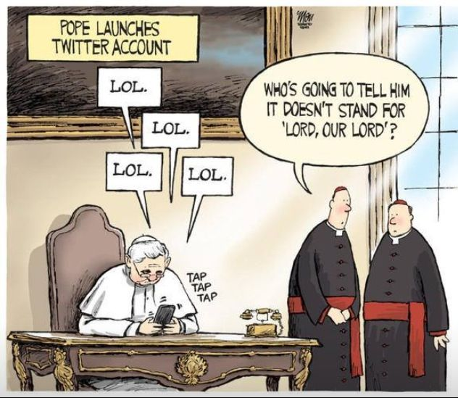

We will be using the following platforms to communicate throughout the year:

Zoom
We will be using Zoom for all of our online classes. You will receive
a Meeting ID and Password for each class, the week beforehand.

MyParish App
We will be using the MyParish App for a lot of communication
this year, particularly reminders of when paperwork is due
and the Meeting ID and Password for the classes on Zoom.

Google Classroom
Since we will be doing so many things online this year,
we will be using Google Classroom as our “paperwork hub”.
All of the pertinent forms that need to be filled out throughout the year,
and their due dates, will be accessible through our Google Classroom.
You can also upload any completed forms to the Google Classroom, at any time.

____________________________________________________

Cari Weibel
Coordinator of Youth Ministries

St. Lawrence
(317) 546-4065, ext. 326
cweibel@saintlawrence.net
Office Hours
Wednesdays and Fridays
St. Matthew
(317) 257-4297, ext. 2210
cweibel@saintmatt.org
Office Hours
Tuesdays and Thursdays

