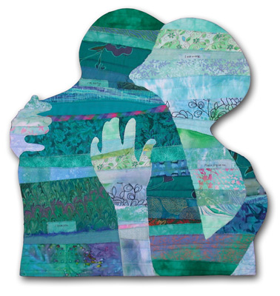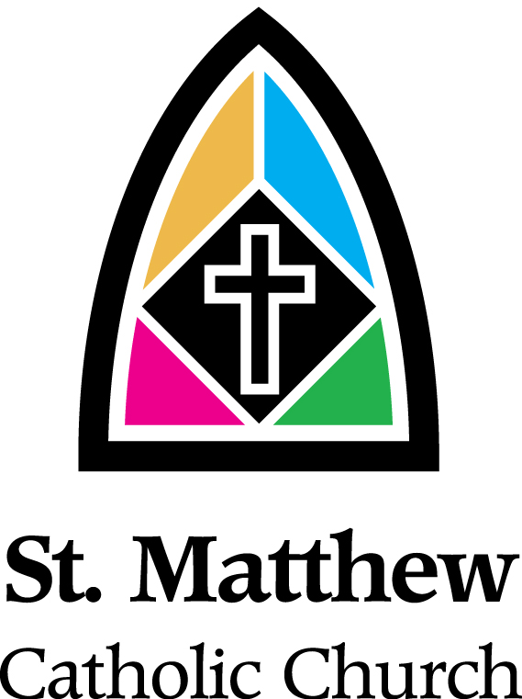

Sacrament Preparation Program St. Matthew Parish
First Reconciliation/First Eucharist
The program
Our program here at Saint Matthew consists of three parents/child gatherings to prepare for Reconciliation and two parents/child gatherings and a parents/child retreat day to prepare for First Eucharist. Parents, teachers and the DRE are the primary catechists during this formation process. The parents/child gatherings are meant to be interactive, informative and interesting. The goal of these gatherings is to help the parents and children learn/relearn together the beauty of the Sacraments and to develop a closer relationship to God and one another through the process. There is a folder that will guide us through the process. Some of the lessons will be focused on in our gatherings, some will be conducted in the school or Family Faith Formation sessions and some at home. Babysitting is available at all gatherings. During each gathering we hear important stories from the Bible, have special prayer opportunities, time to share faith with one another as a family, learn about love and forgiveness in preparation for Reconciliation, and learn about the Mass and all of the special parts as we prepare for Eucharist.

Age
Sacrament Preparation for First Reconciliation and First Eucharist takes place traditionally during 2nd grade. If there is a need for preparation for these sacraments at other grades or ages, contact Jackie Noll.

Reconciliation
Reception of the Sacrament of Reconciliation will take place in a separate reconciliation service one evening in the fall. This is a family service and all family members are encouraged and invited to attend. Babysitting is available. The evening begins with a communal penance service for the group and several priests are available to hear reconciliations. We encourage all parents to receive the sacrament that evening as well. After all in the family have received the sacrament the family is invited to follow several stations together around the church to further build the family relationship and promote the wonderful feelings of love and forgiveness that are found in this sacrament. A reception follows this service.

Eucharist
The First Eucharist Liturgy takes place late April or early May. This is a separate liturgy for the families of the First Eucharist children and their guests. Families will each be given a pew and the First Eucharist child will sit with their parents during the liturgy. At the time of First Eucharist all children will be receiving with their parents. After all children have received other guests and family members will be invited to receive Eucharist.

Rite of Enrollment
The children preparing to receive First Reconciliation and Eucharist will be involved in a rite of enrollment during a Sunday Liturgy. This is an important step for the family as they are able to state their intention. It is also important for the parish to know of and pray for the many children and their families as they prepare for these sacraments. This rite of enrollment will take place in early fall.

Blessing Cup Meal
This meal is a special time for the parents and their child as they approach First Eucharist. A Blessing Cup is made by the parents and child during the retreat day. The child is then given the Blessing Cup at this special meal. It is also a time for the family to focus on the many blessings in their lives and experience some giving and receiving of blessings themselves. This meal also serves as a continuation of the gatherings as we continue to explore together the beauty of our Eucharistic Liturgy. This meal is for the parents and the child. Babysitting will be available for other siblings.

Banners
Banner packets will be given to each family during one of the First Eucharist Gatherings. These banners will be made at home. Each banner will have the family name and can be decorated with any materials the family would like to use. The banners are to be returned at The Blessing Cup Meal and will be displayed during the First Eucharist Liturgy and during that weekend’s liturgies so the parish can celebrate those joining us at the Eucharistic Table for the first time!

Rehearsal
There is a parent/child rehearsal that takes place a week before the liturgy. This is important as the children and parents are more comfortable and are able to live the liturgy more fully when they are not as nervous about what to do on that special day.

Dress
First Eucharist is NOT about what the children wear! We want the child’s experience of First Eucharist to be about receiving Jesus. So, if you follow this guideline, it will make the sacrament even more special: Spend as much time talking as a family about the sacrament and sharing your faith as you do looking for and talking about the clothes that your child will wear that day!! With that being said, girls traditionally wear white dresses and boys traditionally wear a coat and tie to commemorate the very special nature of the Sacrament they are receiving.

Cost
The cost for Sacrament Preparation is $90 per child. This covers the cost of the catered Blessing Cup Meal, the Blessing Cups and the Banner Packets. If there is financial concern, please let Jackie Noll know and scholarships will be given.

Holy Thursday Liturgy
It has been the tradition here at Saint Matthew the past few years for the First Eucharist Candidates to have a special role at this very special Holy Week Liturgy where our wonderful “Eucharistic Liturgy” began.

Weekend Masses
The First Eucharist Liturgy does not fulfill the Sunday obligation. All children are encouraged to wear their First Communion clothes to Mass when they attend that weekend so that the parish can celebrate as these children join us at the Sunday parish liturgy for the first time!

If you have further questions regarding Sacrament Preparation please contact Jackie Noll at jnoll@saintmatt.org or 257-4297 x2215.

