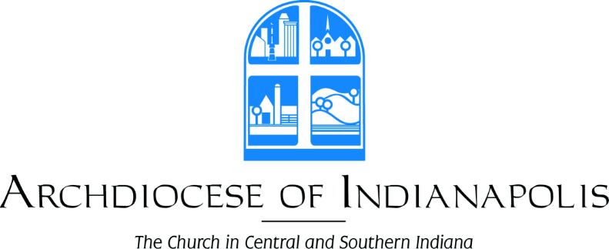

The Christmas Season will soon be upon us – and we want to help you and your family get ready
for BOTH the 4th Sunday of Advent and Christmas!

This year there are back-to-back Mass obligations. With two obligations, that means TWO masses!

Not sure how to fulfill these obligations? Use this helpful chart!
Saturday, December 23
5:00 p.m.
Monday, December 25
Sunday, December 24

4th Sunday of Advent Obligation
Select one from either day on the right
10:00 a.m.
9:30 a.m.

Christmas Obligation

Select one from either day
Sunday, December 24
10:00 p.m.
4:00 p.m.

REMEMBER: It’s NOT possible to fulfill both obligations with only one Mass! Two Masses are needed!
Jesus wants to see you twice!

Please consult your parish bulletin or website for the specific mass times each day.

If there are any questions, please do not hesitate to contact your pastor or PLC.

